IN THE CIRCUIT COURT OF THE 20TH JUDICIAL CIRCUIT
SAINT CLAIR COUNTY - BELLEVILLE, ILLINOIS

SPECIALIZED LOAN SERVICING, LLC
Plaintiff, | Case No. 18 CH 284
vs.
vs. | Property Address:  2333 Cynthia St.  Cahokia, IL 62206
OSIRIS TUCKER; THE BANK OF NEW YORK MELLON F/K/A THE BANK OF NEW YORK, AS SUCCESSOR TRUSTEE TO JPMORGAN CHASE BANK, N.A., AS TRUSTEE ON BEHALF OF THE CERTIFICATEHOLDERS OF THE CWHEQ INC., CWHEQ REVOLVING HOME EQUITY LOAN TRUST, SERIES 2005-1; UNKNOWN OWNERS AND NON-RECORD CLAIMANTS
Defendant(s).

NOTICE OF FILING

TO: See Attached Service List
PLEASE TAKE NOTICE that on June 12, 2018, our office filed with Clerk of the Circuit Court of
St. Clair County our Appearance and Answer, a copy of which is attached hereto and served upon you.
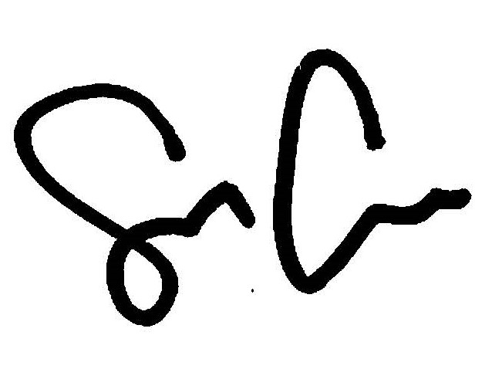
By: ___________________________________
Shaun Callahan
Attorney, Marinosci Law Group, P.C.
ARDC No.: 6296022

CERTIFICATE OF SERVICE

I, Shaun Callahan, hereby certify under penalty of perjury and 735 ILCS Sec. 1-109, that I caused to be served on the members of the attached service list, the attached document, by mailing a copy via electronic mail or by US Mail, postage pre-paid in a sealed envelope at 134 N. LaSalle St., Chicago, Illinois, as so noted below on June 12, 2018, before the hour of 5:00 p.m.
By: ___________________________________
Shaun Callahan
Attorney, Marinosci Law Group, P.C.
ARDC No.: 6296022
MARINOSCI LAW GROUP, P.C.
134 N. LaSalle Street, Suite 1900
Chicago, IL 60602
Telephone: 312-940-8580
Fax: 401-234-5130
ARDC No.: 6296022
mlgil@mlg-defaultlaw.com

SERVICE LIST

ANSELMO LINDBERG & ASSOCIATES LLC
Via Electronic Mail: IllinoisCourts@AnselmoLindberg.com

OSIRIS TUCKER
2333 Cynthia St.
Cahokia, IL 62206
Via USPS

IN THE CIRCUIT COURT OF THE 20TH JUDICIAL CIRCUIT
SAINT CLAIR COUNTY - BELLEVILLE, ILLINOIS

SPECIALIZED LOAN SERVICING, LLC
Plaintiff, | Case No. 18 CH 284
vs.
vs. | Property Address:  2333 Cynthia St.  Cahokia, IL 62206
OSIRIS TUCKER; THE BANK OF NEW YORK MELLON F/K/A THE BANK OF NEW YORK, AS SUCCESSOR TRUSTEE TO JPMORGAN CHASE BANK, N.A., AS TRUSTEE ON BEHALF OF THE CERTIFICATEHOLDERS OF THE CWHEQ INC., CWHEQ REVOLVING HOME EQUITY LOAN TRUST, SERIES 2005-1; UNKNOWN OWNERS AND NON-RECORD CLAIMANTS
Defendant(s).

APPEARANCE

I, the undersigned, hereby enter my appearance on behalf of Defendant: THE BANK OF NEW YORK MELLON F/K/A THE BANK OF NEW YORK, AS SUCCESSOR TRUSTEE TO JPMORGAN CHASE BANK, N.A., AS TRUSTEE ON BEHALF OF THE CERTIFICATEHOLDERS OF THE CWHEQ INC., CWHEQ REVOLVING HOME EQUITY LOAN TRUST, SERIES 2005-1.
By: ___________________________________
Shaun Callahan
Attorney, Marinosci Law Group, P.C.
ARDC No.: 6296022

MARINOSCI LAW GROUP, P.C.
134 N. LaSalle Street
Suite 1900
Chicago, IL 60602
Telephone: 312-940-8580
Fax: 401-234-5130
ARDC No.: 6296022
mlgil@mlg-defaultlaw.com

IN THE CIRCUIT COURT OF THE 20TH JUDICIAL CIRCUIT
SAINT CLAIR COUNTY - BELLEVILLE, ILLINOIS

SPECIALIZED LOAN SERVICING, LLC
Plaintiff, | Case No. 18 CH 284
vs.
vs. | Property Address:  2333 Cynthia St.  Cahokia, IL 62206
OSIRIS TUCKER; THE BANK OF NEW YORK MELLON F/K/A THE BANK OF NEW YORK, AS SUCCESSOR TRUSTEE TO JPMORGAN CHASE BANK, N.A., AS TRUSTEE ON BEHALF OF THE CERTIFICATEHOLDERS OF THE CWHEQ INC., CWHEQ REVOLVING HOME EQUITY LOAN TRUST, SERIES 2005-1; UNKNOWN OWNERS AND NON-RECORD CLAIMANTS
Defendant(s).

ANSWER TO AMENDED COMPLAINT TO FORECLOSE MORTGAGE

NOW COMES Defendant, THE BANK OF NEW YORK MELLON F/K/A THE BANK OF NEW YORK, AS SUCCESSOR TRUSTEE TO JPMORGAN CHASE BANK, N.A., AS TRUSTEE ON BEHALF OF THE CERTIFICATEHOLDERS OF THE CWHEQ INC., CWHEQ REVOLVING HOME EQUITY LOAN TRUST, SERIES 2005-1, by and through its attorneys, MARINOSCI LAW GROUP, P.C. and in answer to the Amended Complaint in the above-captioned case states as follows:
1. Defendant admits the allegations in paragraph 1.
2. Defendant neither admits nor denies paragraph 2, since it has insufficient knowledge to form a belief as to the truth thereof, but demand strict proof of same.
3. Defendant neither admits nor denies paragraph 3, subparagraphs (A), (B), (C), (D), (E), (F), (G), (H), (I), (J), (K) since it has insufficient knowledge to form a belief as to the truth thereof, but demands strict proof of same.
4. Defendant admits the allegations in paragraph 3, subparagraph (L), furthermore, attached as Exhibit A to its Answer is a true and correct copy of its recorded Mortgage. Said mortgage is a valid second lien on the subject premises, subordinate only to the first lien held by SPECIALIZED LOAN SERVICING, LLC.
5. Defendant neither admits nor denies paragraph 3 subparagraphs (M), (N), (O), (P), since it has insufficient knowledge to form a belief as to the truth thereof, but demands strict proof of same.
WHEREFORE, Defendant, THE BANK OF NEW YORK MELLON F/K/A THE BANK OF NEW YORK, AS SUCCESSOR TRUSTEE TO JPMORGAN CHASE BANK, N.A., AS TRUSTEE ON BEHALF OF THE CERTIFICATEHOLDERS OF THE CWHEQ INC., CWHEQ REVOLVING HOME EQUITY LOAN TRUST, SERIES 2005-1, prays that this Court:
- Find that Defendant has a valid and enforceable lien on the subject property, subordinate only to that of Plaintiff;
- Include Defendant’s interest in any judgment of foreclosure and sale entered herein;
- Allow Defendant to offset its debt against its bid in the event that Defendant bids at judicial sale;
- Grant any further relief the Court deems just and equitable.

Respectfully submitted,

By: ___________________________________
Shaun Callahan
Attorney, Marinosci Law Group, P.C.
ARDC No.: 6309682
MARINOSCI LAW GROUP, P.C.
134 N. LaSalle Street
Suite 1900
Chicago, IL 60602
Telephone: 312-940-8580
Fax: 401-234-5130
ARDC No.: 6296022
mlgil@mlg-defaultlaw.com

